**Homework 1**

1. Visit one of the stores that sells textbooks. For 10 or more textbooks, record the department abbreviation and the course number (for example ISM 6930), the price of a new textbook, and whether the book is required, recommended, or optional. Create and print a SAS dataset with this information. Turn in the program, the log file, and the output. (10 points)

Code:

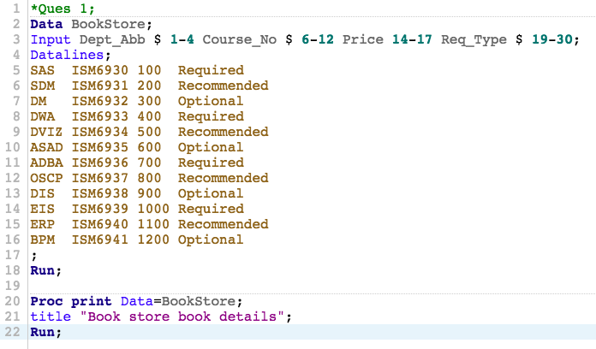

Log:

|  |
| --- |
| 1 OPTIONS NONOTES NOSTIMER NOSOURCE NOSYNTAXCHECK;  72  73 *Ques 1;  74 Data BookStore;  75 Input Dept_Abb $ 1-4 Course_No $ 6-12 Price 14-17 Req_Type $ 19-30;  76 Datalines;    NOTE: The data set WORK.BOOKSTORE has 12 observations and 4 variables.  NOTE: DATA statement used (Total process time):  real time 0.00 seconds  cpu time 0.00 seconds    89 ;    90 Run;  91  92 Proc print Data=BookStore;  93 title "Book store book details";  94 Run;    NOTE: There were 12 observations read from the data set WORK.BOOKSTORE.  NOTE: PROCEDURE PRINT used (Total process time):  real time 0.06 seconds  cpu time 0.06 seconds      95  96 OPTIONS NONOTES NOSTIMER NOSOURCE NOSYNTAXCHECK;  109 |

Result:

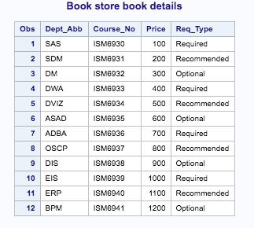

1. Find some soft-drink dispensing machines on campus. Record the following information about 10 or more beverages: Name the beverage, type of container dispensed (can, bottle, juice box, paper cup), price, and whether that drink was sold out when you visited the machine. Use SAS to create and print a dataset with this information. Turn in the program, the log file, and the output. (10 points)

Code:

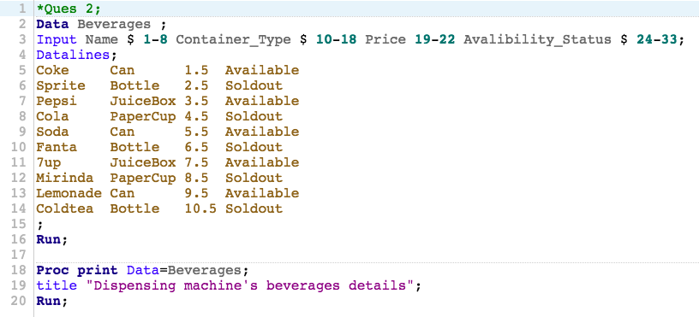

Log:

|  |
| --- |
| 1 OPTIONS NONOTES NOSTIMER NOSOURCE NOSYNTAXCHECK;  72  73 *Ques 2;  74 Data Beverages ;  75 Input Name $ 1-8 Container_Type $ 10-18 Price 19-22 Avalibility_Status $ 24-33;  76 Datalines;    NOTE: The data set WORK.BEVERAGES has 10 observations and 4 variables.  NOTE: DATA statement used (Total process time):  real time 0.00 seconds  cpu time 0.00 seconds    87 ;    88 Run;  89  90 Proc print Data=Beverages;  91 title "Dispensing machine's beverages details";  92 Run;    NOTE: There were 10 observations read from the data set WORK.BEVERAGES.  NOTE: PROCEDURE PRINT used (Total process time):  real time 0.06 seconds  cpu time 0.07 seconds      93  94 OPTIONS NONOTES NOSTIMER NOSOURCE NOSYNTAXCHECK;  107 |

Result:

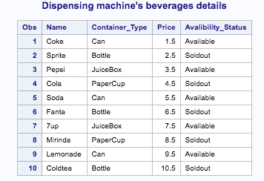

1. Get a copy of a local newspaper or the campus newspaper and find the advertisements for apartment housing in the classified section. Make and print a SAS dataset with the following information about 10 or more apartments: Number of bedrooms (usually abbreviated BR in the ads), number of bathrooms (abbreviated BA), monthly rent in dollars, and the phone number to call for more information. Turn in the program, the log file, and the output. (10 points)

Code:

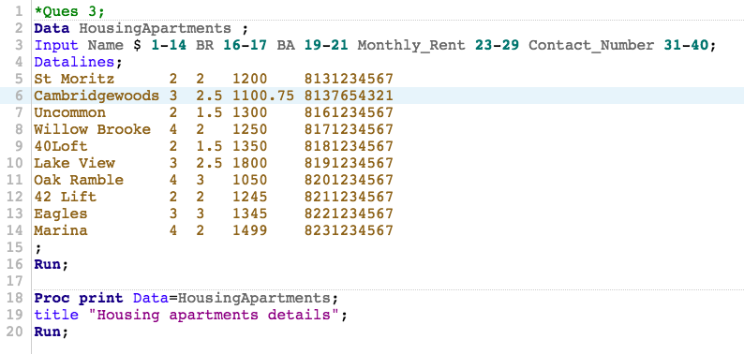

Log:

|  |
| --- |
| 1 OPTIONS NONOTES NOSTIMER NOSOURCE NOSYNTAXCHECK;  NOTE: ODS statements in the SAS Studio environment may disable some output features.  73  74 *Ques 3;  75 Data HousingApartments ;  76 Input Name $ 1-14 BR 16-17 BA 19-21 Monthly_Rent 23-29 Contact_Number 31-40;  77 Datalines;    NOTE: The data set WORK.HOUSINGAPARTMENTS has 10 observations and 5 variables.  NOTE: DATA statement used (Total process time):  real time 0.00 seconds  cpu time 0.00 seconds    88 ;    89 Run;  90  91 Proc print Data=HousingApartments;  92 title "Housing apartments details";  93 Run;    NOTE: There were 10 observations read from the data set WORK.HOUSINGAPARTMENTS.  NOTE: PROCEDURE PRINT used (Total process time):  real time 0.08 seconds  cpu time 0.08 seconds      94  95 OPTIONS NONOTES NOSTIMER NOSOURCE NOSYNTAXCHECK;  108 |

Result:

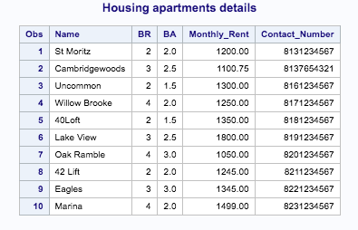

1. For each of the following terms, tell whether that term could be accepted by SAS as a *variable* name. If not, describe why SAS could not accept it. (5 points)

* DOLLARS$ - Not accepted as $ symbol is not allowed
* DIAMETER - Accepted
* 8Y - Not accepted as a variable cannot start with numeric digit. It should start with alphabetic char or underscore
* TREATMENT - Accepted
* _PPX4T_G – Accepted

1. For each of the following terms, tell whether that term could be used as the name of a SAS *dataset*. If not, tell why SAS could not use it. (5 points)

* 1982DATA - Not accepted as the dataset cannot start with numeric digit. It should start with alphabetic char or underscore
* DATA#1 - Not accepted as # symbol is not allowed
* D_A_T_A_ - Accepted
* TRIALDATA - Accepted
* BARNEY - Accepted

1. The following passage appears on page 70 of High School Basketball Rules (10 points)

It has been reported that when using computers to keep statistics, etc., the numbers 0 and 00 are treated as a single number. The action of the committee simply decrees that beginning in (the year) 2000 a team’s squad list shall not contain both Numbers 0 and 00. One of the two may be used, but not both. The solution for teams would be to purchase shirts with either one or the other, but not both numbers.

Suppose that a team has players with Numbers 0 and 00, and you want to keep track of the team’s statistics using SAS. Write an example SAS program with fictional data to show one way in which the two players could be identified as a 0 and 00, respectively.

Code:

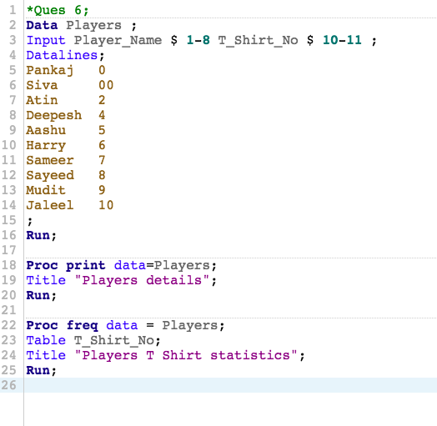

Log:

|  |
| --- |
| 1 OPTIONS NONOTES NOSTIMER NOSOURCE NOSYNTAXCHECK;  72  73 *Ques 6;  74 Data Players ;  75 Input Player_Name $ 1-8 T_Shirt_No $ 10-11 ;  76 Datalines;    NOTE: The data set WORK.PLAYERS has 10 observations and 2 variables.  NOTE: DATA statement used (Total process time):  real time 0.00 seconds  cpu time 0.01 seconds    87 ;    88 Run;  89  90 Proc print data=Players;  91 Title "Players details";  92 Run;    NOTE: There were 10 observations read from the data set WORK.PLAYERS.  NOTE: PROCEDURE PRINT used (Total process time):  real time 0.06 seconds  cpu time 0.06 seconds      93  94 Proc freq data = Players;  95 Table T_Shirt_No;  96 Title "Players T Shirt statistics";  97 Run;    NOTE: There were 10 observations read from the data set WORK.PLAYERS.  NOTE: PROCEDURE FREQ used (Total process time):  real time 0.07 seconds  cpu time 0.07 seconds      98  99  100 OPTIONS NONOTES NOSTIMER NOSOURCE NOSYNTAXCHECK;  113 |

Result:

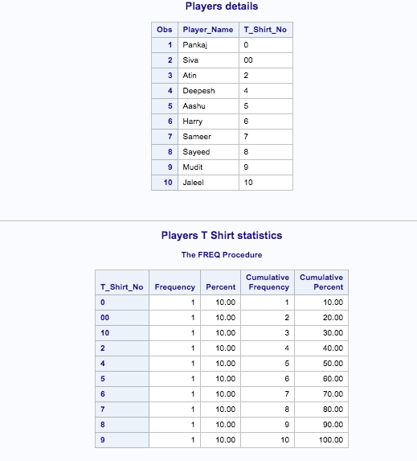

1. Identify which of the following variable name are valid SAS names: (10 points)

Height - Valid

HeingtInCentimeters - Valid

Height_in_centimeters - Valid

Wt-Kg – Invalid as ‘-‘ is not allowed

X123y456 - Valid

76Trombones – Invalid as the dataset cannot start with numeric digit. It should start with alphabetic char or underscore

MiXedCasE - Valid

1. In the following, classify each data set name as valid or invalid. (10 points)

Clinic - Valid

Clinic - Valid

Work - Valid

hyphens-in-the-name - Invalid as ‘-‘ is not allowed

123GO - Invalid as the dataset cannot start with numeric digit. It should start with alphabetic char or underscore

Demographics_2006 - Valid

1. You have a dataset consisting of Student ID, English, History, Math and Science test scores on 10 students. (10 points)
2. The number of variables is __5__
3. The number of observations is __10__
4. True or false: (10 points)
5. You can place more than one SAS statement on a single line. True
6. You can use several lines for a single SAS statement. True
7. SAS has three data types: character, numeric, and integer. False
8. OPTIONS and TITLE statements are considered global statements. True
9. What is the default storage length for SAS numeric variables (in bytes)? (10 points)

8 bytes